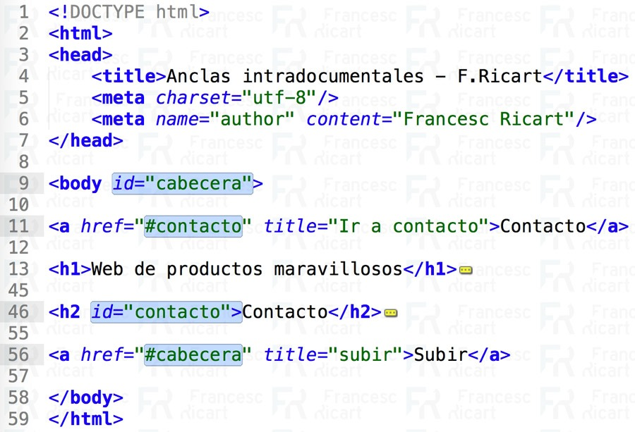
Lehumo Welcome Masehla
ST10536487


web development (introduction)
WEDE5020
Table of Contents
Proposal 1: Small Business 2
1. Organisation Overview 2
2. Website Goals and Objectives 2
3. Current Website Analysis 2
4. Proposed Website Features and Functionality 2
5. Design and User Experience 2
6. Technical Requirements 3
7. Timeline and Milestones 3
8. Budget 3
9. References 3
Proposal 2: Non-Profit Organisation 3
1. Organisation Overview 3
2. Website Goals and Objectives 4
3. Current Website Analysis 4
4. Proposed Website Features and Functionality 4
5. Design and User Experience 4
6. Technical Requirements 4
7. Timeline and Milestones 4
8. Budget 5
9. References 5

Proposal 1: Small Business

1. Organisation Overview
- Name: Verdant Sun Agri-Tech Solutions
- History: Established in 2022, Verdant Sun Agri-Tech Solutions installs solar-powered drip and sprinkler irrigation systems for commercial and smallholder farmers across South Africa.
- Mission & Vision: To help farmers grow more crops using solar-powered irrigation that doesn’t rely on the power grid and is better for the environment.
- Target Audience: Small-to-medium commercial crop farmers, agricultural co-operatives, rural landowners, and local agricultural extension officers.

2. Website Goals and Objectives
- Goals: Get new customers enquiries through an online calculator and provide a place to download product brochures.
- KPIs: Achieve a 5% form submission conversion rate and reach 500 to 1,000 unique monthly website visitors within six months of launch.

3. Current Website Analysis
- Strengths: Active local domain (. co.za) and high-resolution portfolio photography of past solar field installations.
- Weaknesses: The site is non-responsive on mobile layout, has non to zero online tools for customers, and is hard to find on the internet.
- Improvements: Rebuild using a website that works well on phones first with integrated dynamic lead generation forms.

4. Proposed Website Features and Functionality
- Core Pages: Homepage with a hero Call-to-Action (CTA), About Us, Products/Services Catalog, and a Contact Page featuring Google Maps and click-to-WhatsApp messaging.
- Interactive Tool: A custom solar irrigation size and quote estimation calculator built using JavaScript.

5. Design and User Experience
- Colour Scheme: Primary Forest Green, Secondary Sun Gold, and Neutral Off-White.
- Typography & UX: Montserrat headings with Open Sans body text. Structured as a high-contrast, mobile-optimized card layout featuring a sticky top navigation bar.

6. Technical Requirements
- Hosting & Domain: Register a .co.za domain with secure, cloud-based web hosting that includes an SSL certificate.
- Tech Stack: HTML5, CSS3, JavaScript, Git version control, and GitHub repository hosting.

7. Timeline and Milestones
- Weeks 1–2: Requirement gathering, wireframing, and repository setup.
- Weeks 3–4: HTML5 structure and custom CSS styling development.
- Weeks 5–6: JavaScript quote calculator scripting and form validation.
- Weeks 7–8: test the site on phones, write project documentation, and publish the website online.

8. Budget
- Domain & Hosting (1 Year): R1,350.00
- UI/UX Design & Wireframing: R3,500.00
- Front-End Web Development: R8,500.00
- Testing & Final Launch: R2,000.00
- Total Estimated Budget: R15,350.00

9. References
- Department of Agriculture. (2023). Sustainable Agriculture Guidelines. Pretoria.
- World Bank. (2021). Solar Pumping Systems. Washington, D.C.
- Sustainable.co.za (n.d.) Solar Water & Pool Pump Kits. Available at: https://www.sustainable.co.za/collections/pump-kits (Accessed: 3 August 2026).

Proposal 2: Non-Profit Organisation

1. Organisation Overview
- Name: Pokwane Harvest Hope Community Network
- History and Background: Formed in 2020, Pokwane Harvest Hope community network is a non-profit organisation dedicated to battling rural household food insecurity, empowering and uplifting smallholder farming communities, and promoting involvement in farming and sustainable rural land utilization.
- Mission & Vision: To build self-sustaining rural agricultural communities through localized food production, ecological farming education, and spatial land optimization.
- Target Audience: Smallholder rural farmers, community leaders, agricultural volunteers, and environmental researchers.

2. Website Goals and Objectives
- Primary Goal: To establish an accessible, informative, and engaging web platform that connects smallholder farmers with educational resources, recruits agricultural volunteers, attracts corporate sponsorship, and showcases regional farming research.
- Key Performance Indicators (KPIs):
  - Onboard 50+ active agricultural volunteers and sponsors per quarter via a form both volunteers and sponsors can use.
  - Achieve 200+ monthly downloads of rural agricultural guides and spatial research documents.
  - Provide clear, accessible contact and location details for rural operational hubs across district municipalities.

3. Current Website Analysis
- Strengths: Strong social media integration and compelling community storytelling copy.
- Weaknesses: Lacks a secure online donation gateway, has confusing navigation menus, and slow media loading times.
- Improvements: Integrate an online donation system using PayFast and streamline user navigation pathways.

4. Proposed Website Features and Functionality
- index.html (Home): Hero banner, mission statement, core impact areas (communal farming, workshops, spatial planning), and a featured research download section.
- about.html (About Us): Detailed history of the NPO, leadership structure, core values, and community impact metrics across rural districts.
- services.html (Services & Projects): Information on active smallholder support programs, soil/irrigation workshops, and an open-access Resource Library featuring regional agricultural studies.
- enquiry.html (Enquiry): A form in which people can apply to volunteer OR companies can request to sponsor.
- contact.html (Contact Us): Operational hub details, phone numbers, email addresses, and location maps for rural project sites in Vhembe District (Thohoyandou) and Sekhukhune District (Groblersdal).

5. Design and User Experience
- Colour Palette:
- Brown(earthy)
- Leaf Green
- Cream White
- Typography & Layout: Clean arial fonts, for structured with information boxes that are easy to read, and high-contrast buttons for maximum readability.

6. Technical Requirements

Github: version controlled and hosted publicly via Github / Github pages.
- Tech Stack: HTML5, CSS3, Vanilla JavaScript, PDF Resource Embedding, Git & GitHub for version control. This stack will be used to build fast, mobile friendly website and keep all codes changes tracked.

7. Timeline and Milestones
- Weeks 1–2: Requirements gathering, proposal finalization, and document/asset sourcing.
- Weeks 3–4: File directory creation, base HTML structure development across all 5 pages, and internal link integration (Part 1).
- Weeks 5–6: CSS styling, responsive layout design, and colour palette implementation (Part 2).
- Weeks 7–8: JavaScript form logic, cross-browser testing, README compilation, and GitHub deployment (Part 3).

8. Budget
- .org.za Domain name & DNS Configuration: R350.00
- UI/UX Architecture & Content Sourcing: R2,500.00
- Front-End HTML5/CSS3 Web Development: R6,000.00
- Testing, QA & Deployment: R1,150.00
- Total Estimated Budget: R10,000.00

9. References
- Food and Agriculture Organization (FAO). (2022) Smallholder agriculture and sustainable land management in Sub-Saharan Africa. Rome: FAO.
- Sekhukhune District Municipality. (2020) Review of the District Spatial Development Framework (SDF). Sekhukhune: Sekhukhune District Municipality.
- Verdant Agri-Tech. (2024) Digital solutions for African agriculture. Available at: https://verdant.ng (Accessed: 13 August 2026).
- Vhembe District Research Group. (2021) 'Understanding the drivers of production in South Africa farming systems: A case study of the Vhembe District, Limpopo, South Africa', South African Journal of Agricultural Extension, 49(2), pp. 45–58

